Papers:
Edmund Chang et al. 2002: Storm Track Dynamics, J. Climate, 15, 2163-2183.

Purpose:
This is a review of the current state of observational, theoretical, and modeling knowledge of the midlatitude storm tracks in the Northern Hemisphere cool season. The final objective of storm track research is to improve the accuracy of day-to-day weather forecast in the midlatitude area, where cyclones are most likely to happen.

Background:
People’s knowledge of storm track first came from surface-level field observations of storm activities, which includes their locations and their preferred paths of travel. In 1888, Hinman first summarized these observations into a global storm activity distribution figure (Figure 1). In this figure, there are two maximal cyclone occurrence centers located in the Northwestern Pacific Ocean and the Northwestern Atlantic Ocean respectively and one weaker cyclone activity center over the Mediterranean. Both the Pacific Storm Track Center (PST) and the Atlantic Storm Track Center (AST) are propagating from the north to the south. Since their activities affect most of the earth’s population, they would be the focus of our future discussion. Even though these observations are similar to the modern synoptic picture of the cyclone occurrence frequency and cyclogenesis (Pettersen, 1956), no systematic analysis method about storm track activities had been formed at that time. Until 1970s, Blackmon found that 500mb geopotential height is a good tool to study cyclone activities. He expanded 10-year record of 500mb geopotential height for the Northern Hemisphere into spherical harmonics and filtered them in the time domain. By drawing maps of the root-mean-square height corresponding to different spatial scales and frequency bands, he could isolate spurious, high frequency parts of the field from the physically meaningful parts (Blackmon, 1976). This ‘bandpass’ analysis method can be carried out at all levels of the atmosphere and make 3-dimentional picture of the storm track possible. And a new definition of storm track emerged from this ‘new’ technique: “geographically localized maxima in bandpass transient variance”. In fact, it shows a good agreement with ‘old Hinman map’ by capturing both the PST and the AST centers in the 250mb Z (geopotential height) contour and 850mb polar-ward heat fluxes contour.
Generally a storm track structure consists of a storm track entrance where has a strong surface baroclinic system serving as a ‘seed’, a large middle region where the baraclinic system is weaker but eddy activity is strong and the amount of eddy energy is largest, and a termination region where eddy breaks and there is very low surface baroclinicity without eddy generation.
A systematic shift of storm track’s geophysical location or the strength can substantially affect precipitation anomalies with consequent impacts on regional climates. For example, during strong El Nino events, the normal Western Pacific Warm Pool and Eastern Pacific Cold Tongue structure is broken. The Pacific Storm Center moves downstream; causes increased rainfall across the southern tier of the US and in Peru, which has caused destructive flooding, and drought in the West Pacific, sometimes associated with devastating brush fires in Australia.

Methods:
The study of storm track includes three steps: observation, theorization and modeling. Like all kinds of sciences, observation is the basis of further research. When we try to explain what we ‘see’, a theory is formed. Modeling is proved to be an effective way to simulate the nature processes, which could never be tried out under the laboratory conditions. Both the theory and model results need to be consistent with observations, otherwise necessary improvements should be done.
The best way to recognize storm tracks is by bandpass transient variances of any quantity. Generally, eddy amplitudes during the Northern Hemisphere cool season are maximal over a band running across the midlatitudes, extending roughly from the Western North Pacific, across North America and the North Atlantic, into Northern Europe. The storm track’s seasonal variations are closely related to zonal mean polar-to-equator temperature gradient. The storm track center moves equatorward from fall to midwinter (Jan) and then moves poleward gradually. In particular, the Pacific Storm Track exhibits a marked minimum during midwinter when the background baroclinicity is strongest. The mechanism responsible for this ‘midwinter’ minimum is still under active debates. Interannual variance of storm track structure shows close relation on mean flow changes. The most obvious example of this kind of change is the ENSO event: a reversed but weaker Walker circulation and an enhanced Hadley circulation make the Pacific Storm Track center propagates downstream. Storm track structure also shows significant decadal variance, but the mechanism is still unknown.
The most well known theory about storm track is baroclinic development, which provides the energy source for pole-up-ward motion of warm air and equator-down-ward motion of cold air. Obviously when the pole-equator temperature gradient is stronger, the eddy movement will also be faster. Sometime temperature gradient is not necessary to maintain a storm track; however stationary waves induced by mountains alone can maintain the baroclinic system. In fact, all of the theories about storm track are intend to explain how storm track is developing from a baroclinic source by focusing on different aspect of the whole process.
These theories are:
- Linear modal instabilities: “linear disturbances can efficiently tap the baroclinic source of energy and grow on zonally symmetric flows.”
- Downstream development: the process of storm track development is not a single time-independent structure a set of some coherent nonlinear baroclinic wave packets.
- Barotropic effects: zonally varying background flow (e.g. varying surface roughness) can act to localize storm tracks.
- Effects of diabatic heating: latent heat exchange between air and water vapor or body can provide energy source or damp the surface temperature perturbation.
- The observed midwinter transient energy budget: the energy budget is a combination of an ageostrophic geopotential flux with the advective energy flux term; a baroclinic generation term; a barotropic conversion term; a mechanical dissipation term and a diabatic generation term.
- Feedback upon the mean flow: interactions between low-frequency variance and high-frequency variance.
Obviously all these theories are effective and important in some specific situation. The accuracy of them will be tested in the form of modeling. In fact, they are not isolated with each other at all; the basic dynamics and thermodynamics are their common basis.

Results:
The direct utilization of storm track theories is to predict storm track activities by modeling. There are two kinds of model:
- AGCMs: all of the relevant physical processes are incorporated into the models. AGCMs are good at capturing the characteristics and propagation of eddies in storm track regions, but cannot directly test the sensitivities of storm tracks to variances of low-frequency flow.
- Storm track modeling: the purpose of this kind of model is to assess interactions between storm track transients and changes in the planetary-scale flow.
The final results and utilization of these models depend on the underline theories. Till now there is no model can capture every detail of storm track at the same time, which reflects that our knowledge about storm track is still not complete and there is a long way to go!

Analysis:
The global distribution of storm track centers (Figure 1) shows a great similarity to the distribution of ocean surface current (Figure 2). Especially in the Northwestern Pacific and Northwestern Atlantic, where both have strong warm surface currents (Kuroshio and Gulf stream). Because the time scale of ocean currents is much longer than a storm track’s life-time (2-7 days). We cannot say that the current is driven by the storm activities. In fact, the driven forces of surface currents are mainly from tropical zonal surface flow (westward trade wind) and the conservation of vorticity. So the currents are more likely affected by tropical mean flow. Therefore, because the surface current can transport warmer water into storm track centers, there could be indirect mechanism between zonal mean flow and storm track locations through the media of ocean current. In order to prove that, we need to first find out how SST changes with currents activities including both seasonal and annual variances. Then we need to know if the SST also has similar seasonal and annual variations as storm track centers did, especially to find out if SST has ‘midwinter minimum’! In the exist models, SST data are only from observations. Maybe that is why they can only capture storm track structure, but cannot predict its sensitivity to climate changes. If in the future, we use fully coupled Ocean and AGCM model to share wind data and SST data with each other, we would expect at least partially improved results in both models.

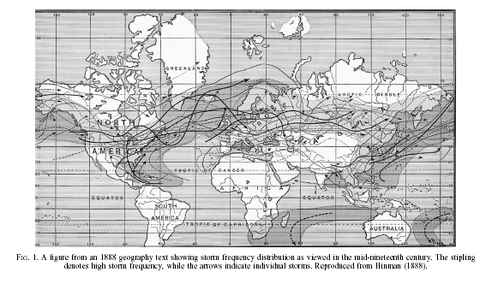
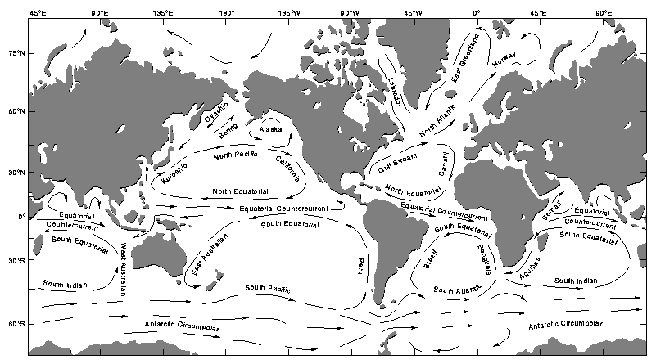
Figure 2. Major surface current

